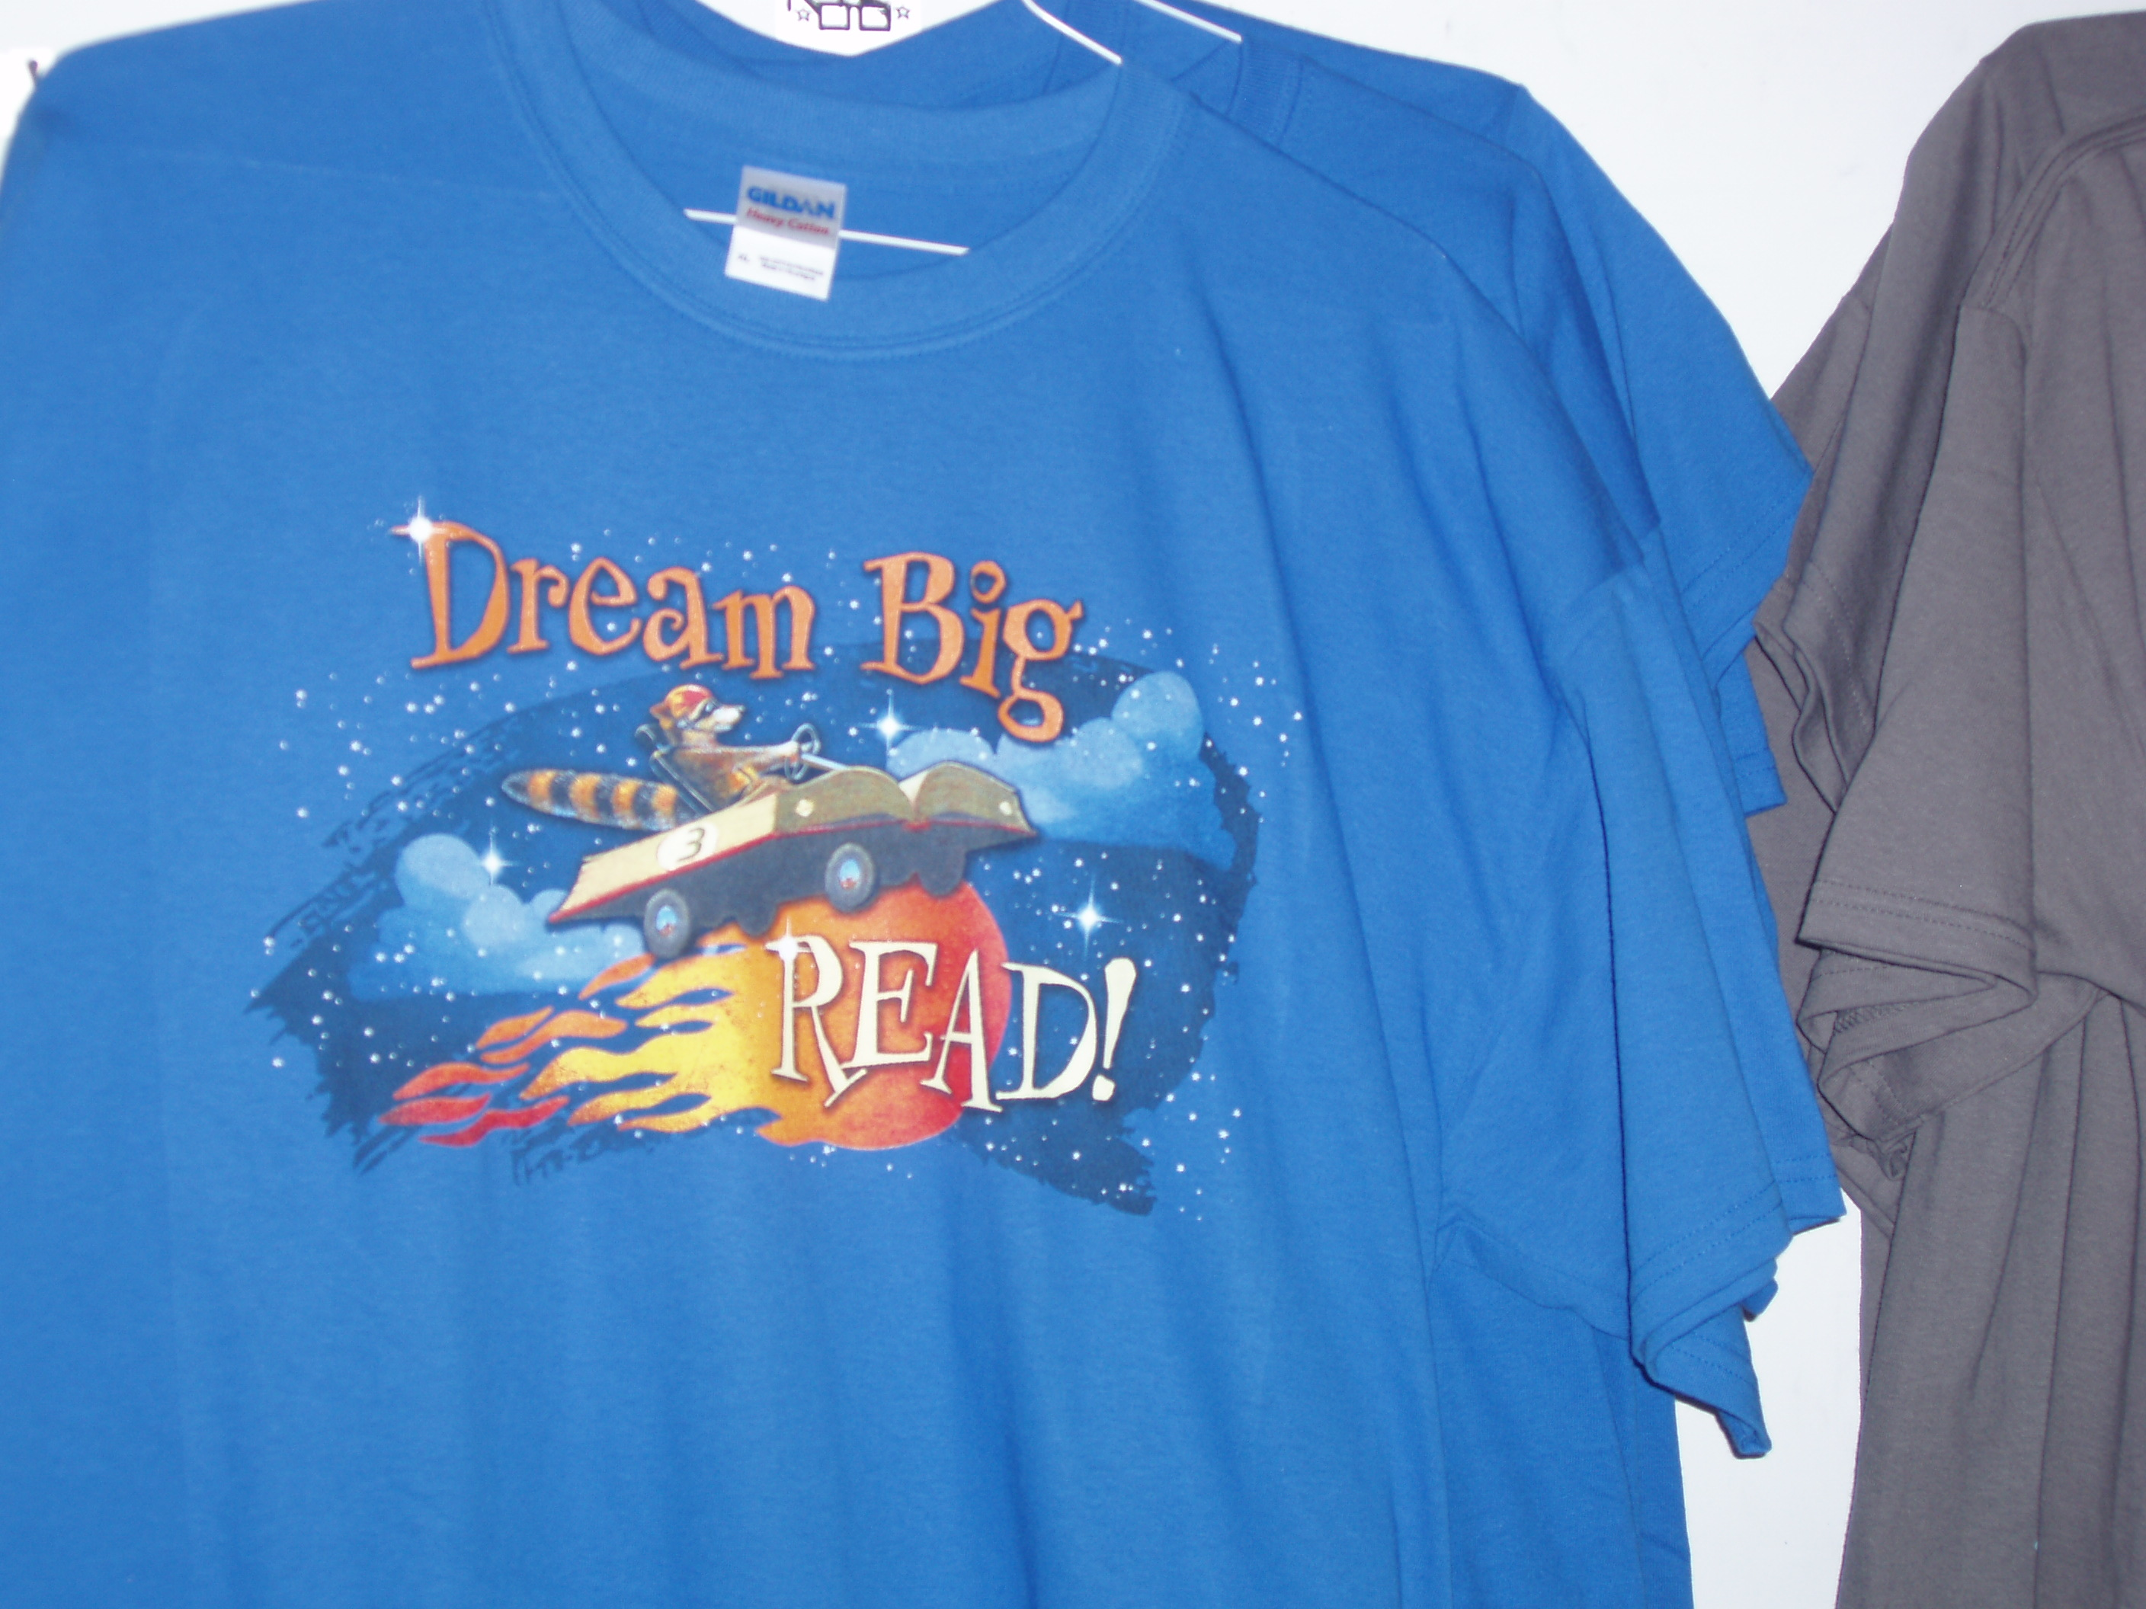
Dream Big READ! T-shirt (royal blue) actual shirt is darker blue than picture – Margie
S M L XL XXL
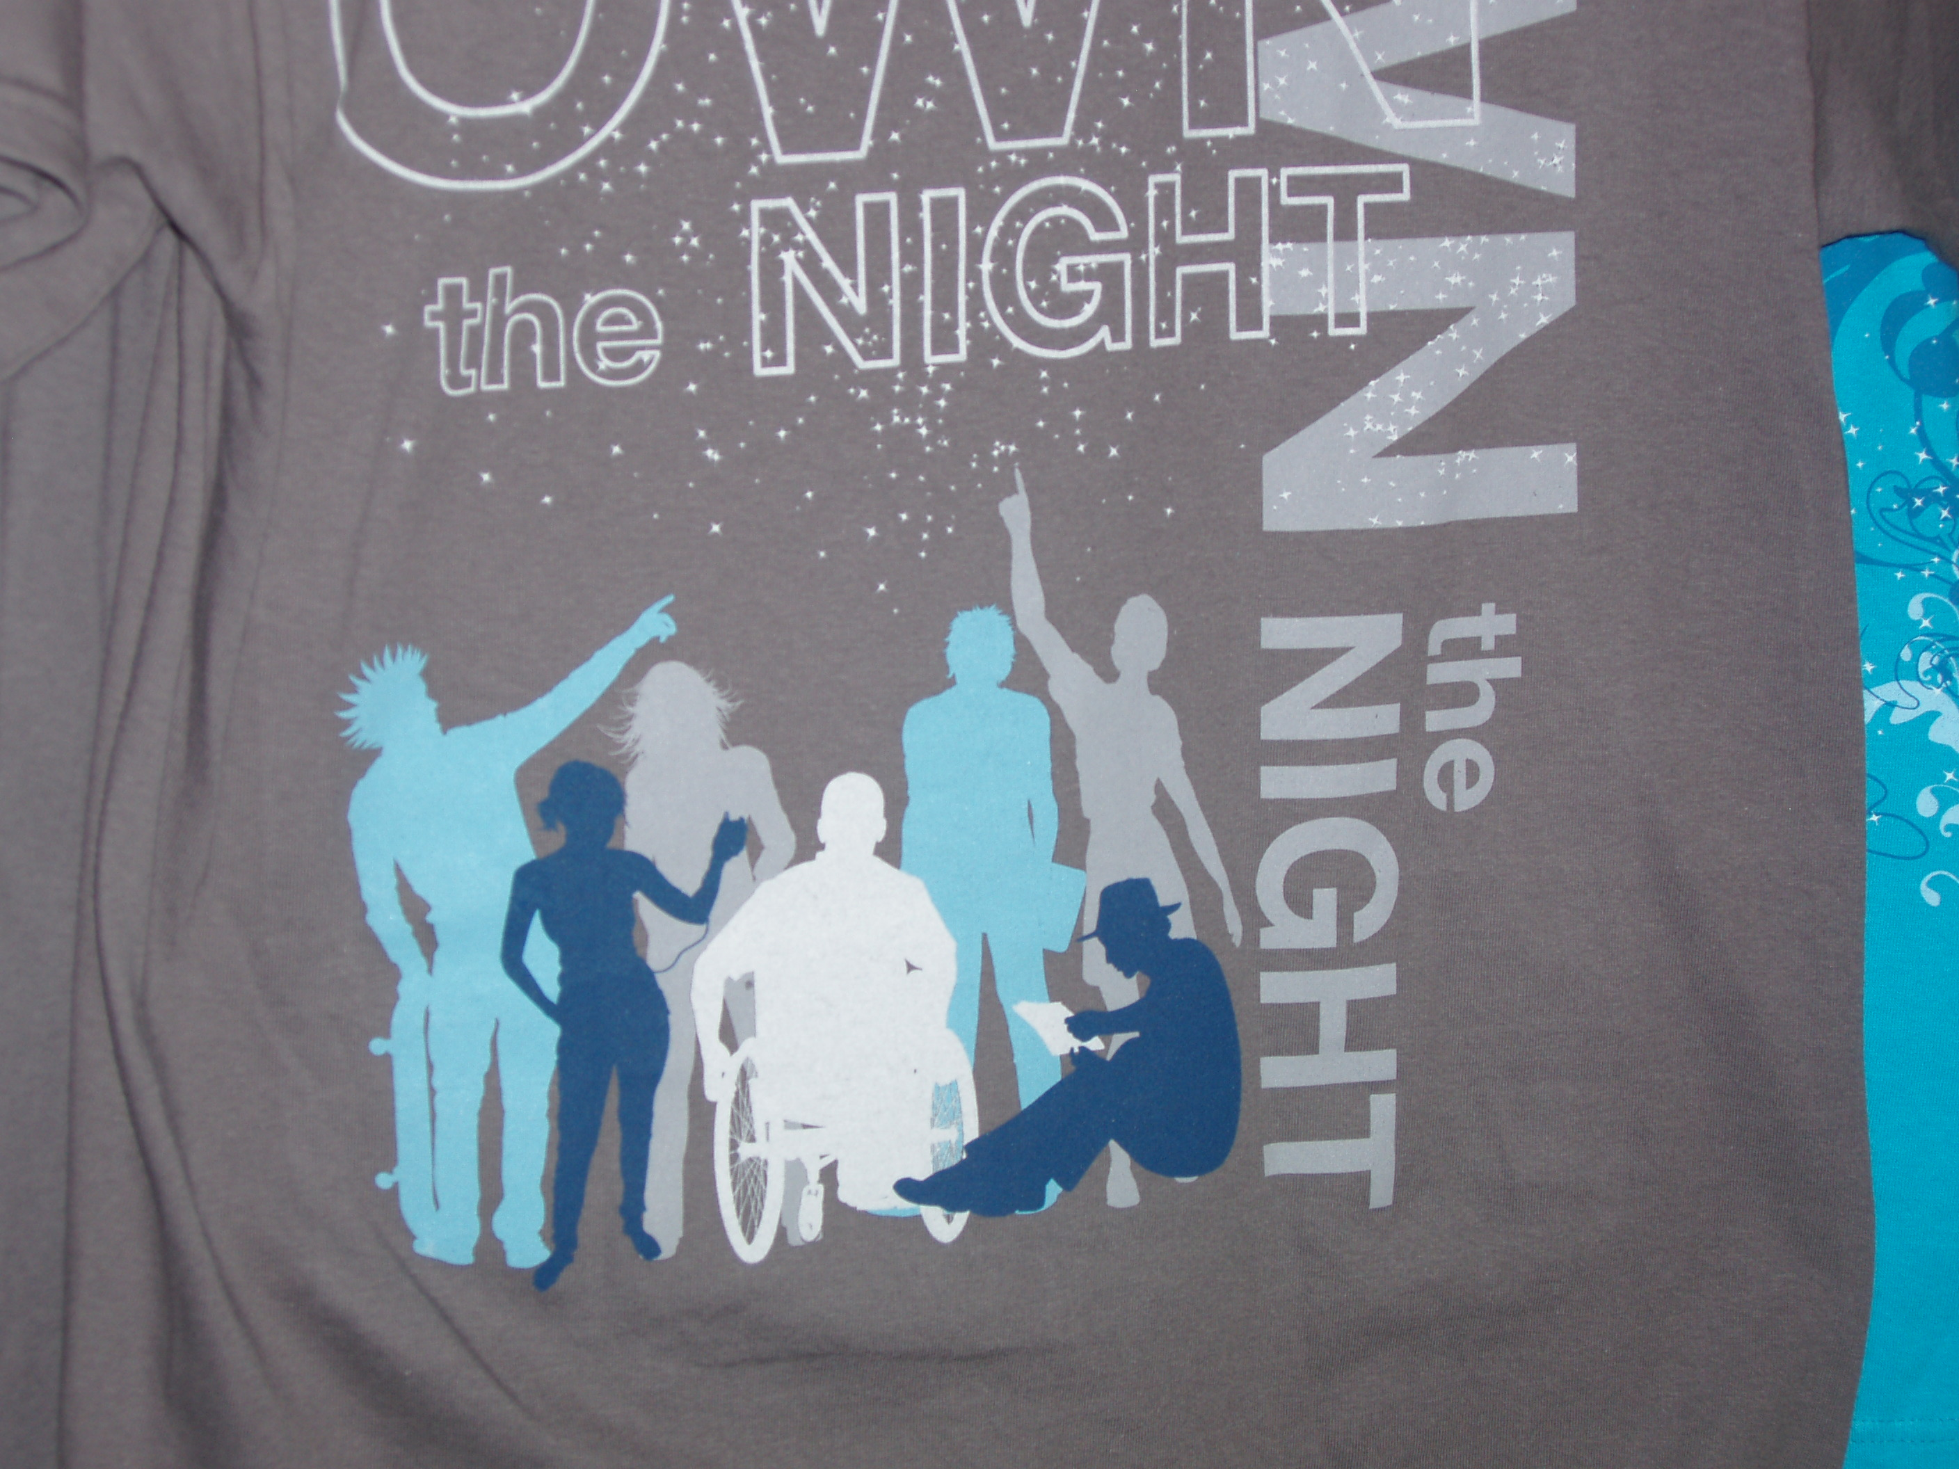
Own the Night T-shirt (Steel Grey) actual shirt looks almost like a dark Olive Green -- Margie
S M L XL XXL
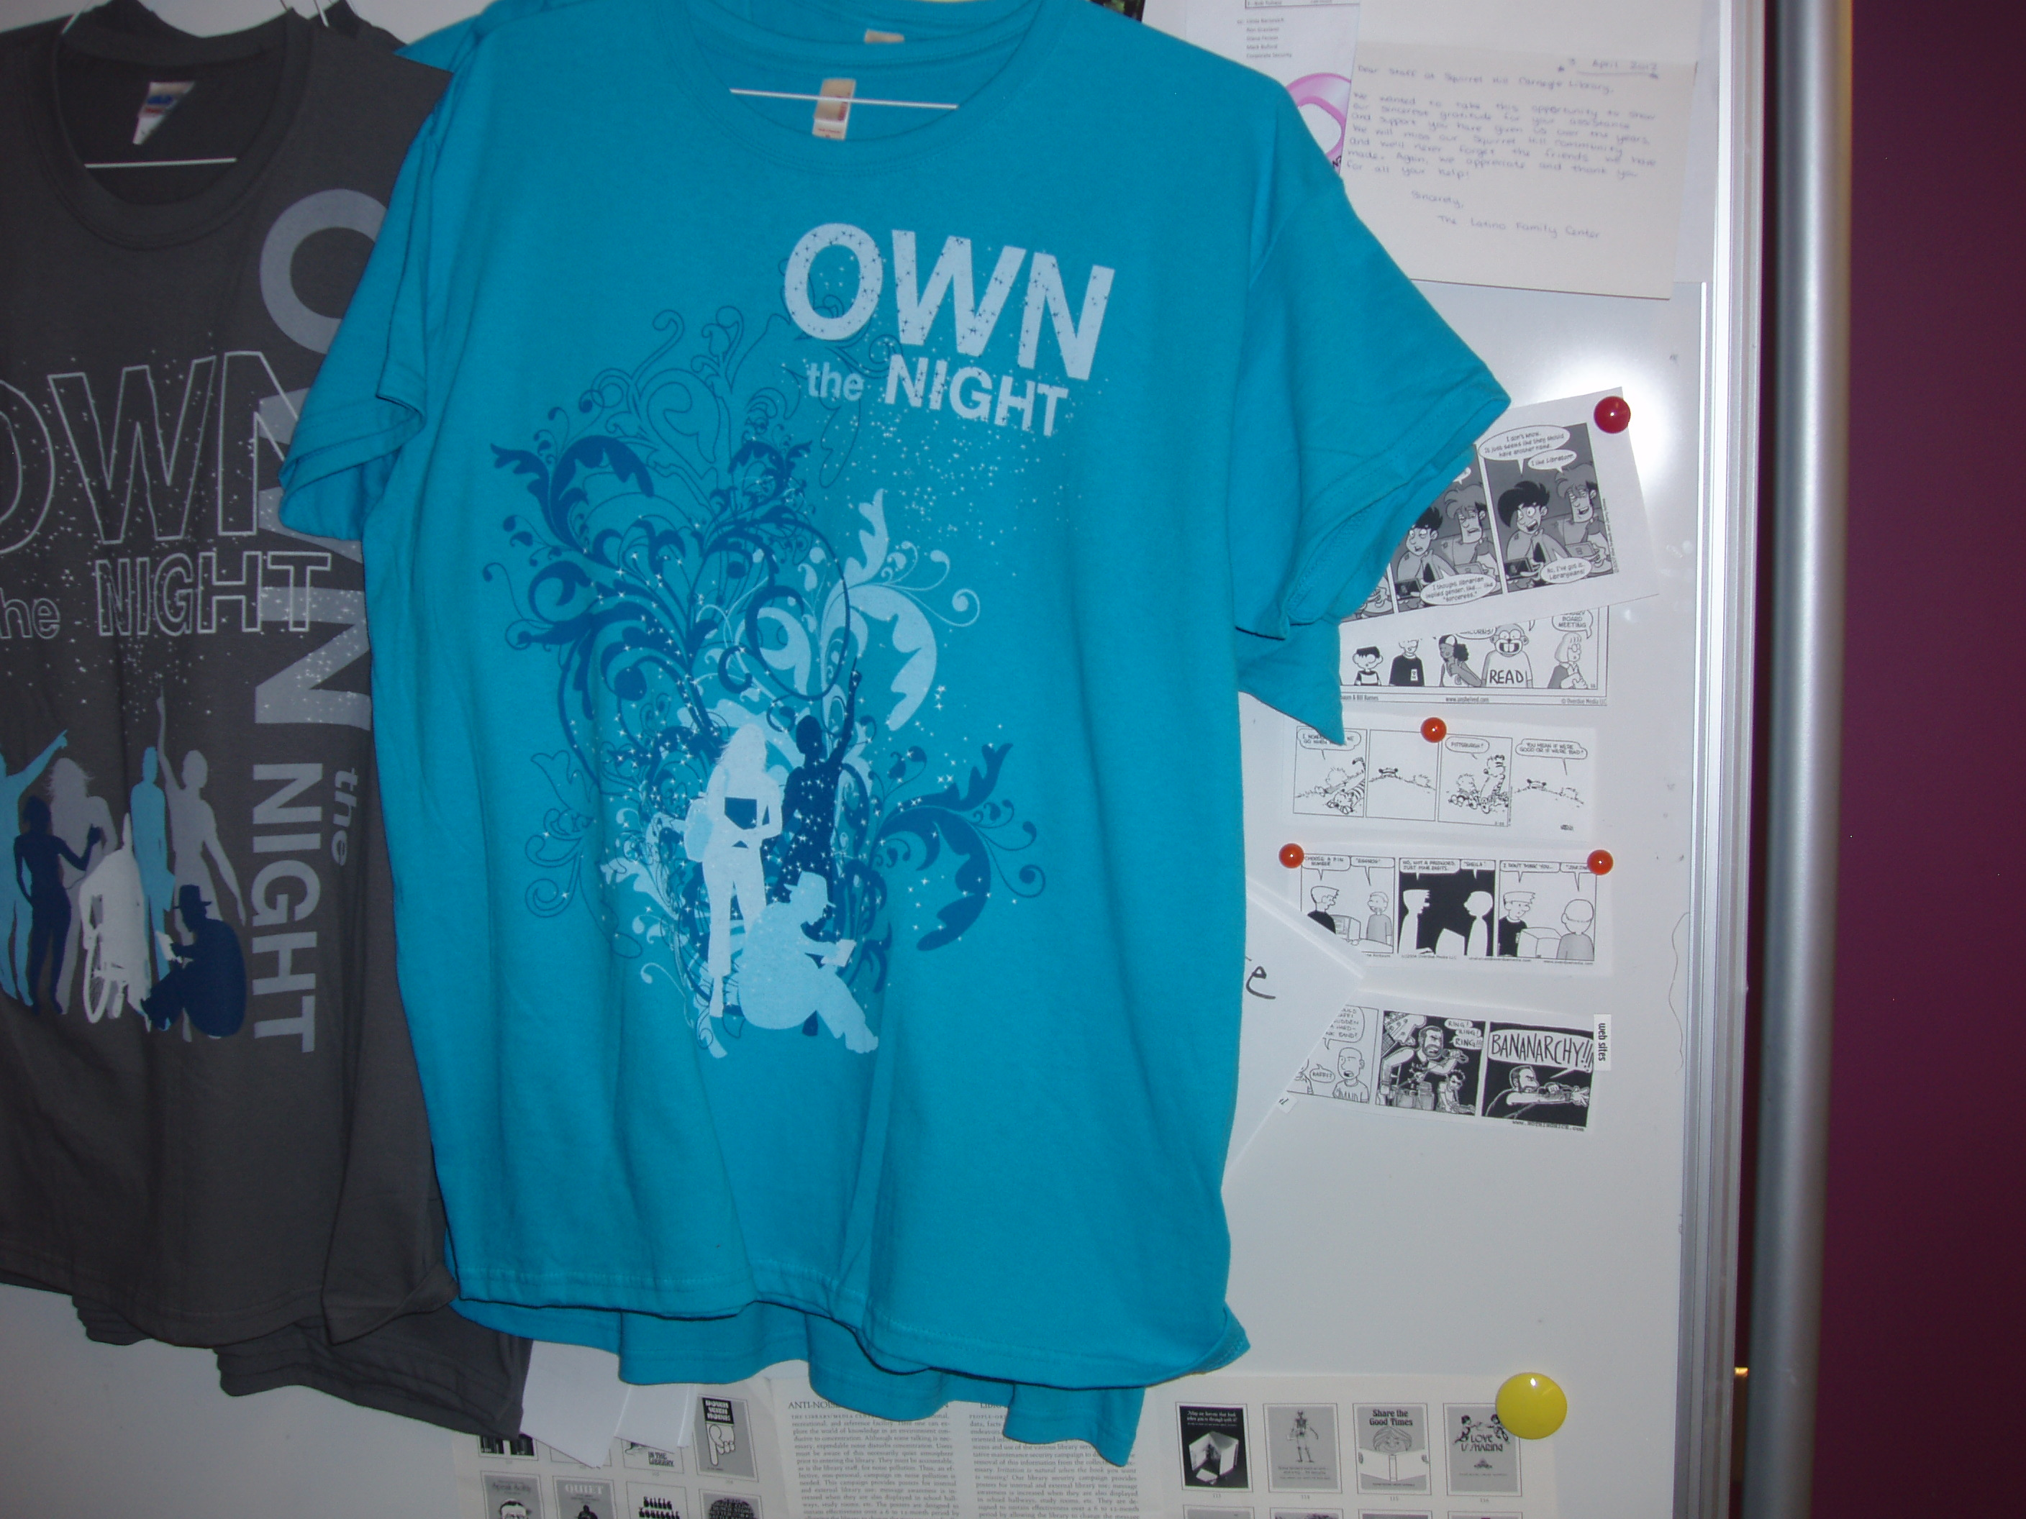
Own the Night T-shirt (Women’s Style – Turquoise)
S M L XL XXL XXXL

